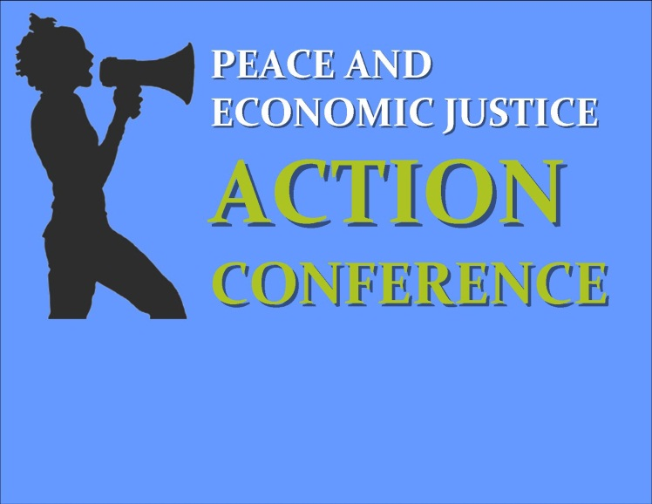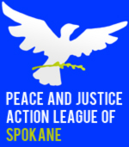

Saturday, March 8, 2014

8:00-9:00 Registration and Networking Breakfast

8:45-9:00 Opening Performances

9:00-9:30 Welcome and Dedication

9:30-9:45 Mixer Break

9:45-11:15 "Education for Action" Workshop Session 1 (90 min)

MLK's Call to Conscience & What It Means in 2014
Ellen Finkelstein, Western Washington Fellowship of Reconciliation
Examine MLK's "Beyond Vietnam" speech (1967, Riverside Church), its impact on American culture, and its relevance in 2014 - including intersectionality, nonviolence, and challenging empire.

Fundraising for Social Change: Asking for Money
Liz Moore, Peace & Justice Action League of Spokane
Creating social change requires resources--both organized people and organized money! The most powerful way groups can pursue their mission with confidence for the future is to build strong relationships with a broad base of everyday people who share your passions and values! Come learn some surprising can-do realities about fundraising and even practice putting those facts into action for causes you care about!

You can make a difference: Abolishing the Death Penalty
Shar Lichty, Peace & Justice Action League of Spokane
Learn more about the myths and facts surrounding the death penalty; gain skills and increase confidence in effectively communicating on the issue; and find out ways you can make a difference from home, the meeting room, or Olympia.

Building Grassroots Power Through Grand Strategy & Creativity
Bill Moyer and Eric Ross, Backbone Campaign
Grand Strategy & Creative Tactics is a signature workshop of Backbone that articulates a set of strategic principles and framework through which our social movement can assess the effectiveness of the tactics we deploy in order to achieve our goals and manifest our vision.

Interrupting Oppressive Statements
Mark Hamlin and Alyssa Henderson, Peace & Justice Action League of Spokane
Come learn and practice some ways to use your voice to challenge prejudice and to accept challenges to our own internalized messed-up learnings. As allies to each other, we have to learn how to challenge oppression in every form. While we all must organize together to act against institutional and cultural oppression, we can act as individuals to challenge other people’s learned prejudices. Interrupting oppressive statements is one important way of confronting prejudice and creating communities and organizations that work for everyone.

The campaign cash tsunami: why it’s happening, what is doing to the country, and how you can stop it
Ted Hensold, Spokane Moves to Amend the Constitution (SMAC)
Participants will learn about the cause of big money campaigns, understand the many ways in which this impacts society, and learn what they can do to help address this problem.

Why Won’t They Listen? Tools For Community Organizers!
Pastor Deb Conklin, The Oak Tree
Many of us have spent years working on justice issues, often with limited success, because we have been using strategies that have limited success. In this work shop we will figure out how to change that.

11:15-11:30 Mixer Break

11:30-1:00 "Education for Action" Workshop Session 2 (90 min)

Nonviolence in Action: Building Community, Building Our Movements Kristin Stoneking, Fellowship Of Reconciliation

Responsibilities and Duties of Board Members To Their Non-Profit Corporation
Mary Giannini
Learn about the structure and functions of a nonprofit corporation and the laws that apply to non-profits; the duties, rights and liabilities of directors serving on the governing board of a non-profit corporation; and the procedures and practices that create effective governance and management.

How to Persuade and Influence Others Through Story Telling
Bart Haggin
Learn how to persuade and influence people using science and storytelling.

Artful Activism
Valerie Waley and Steve (Ziggy) Sigfreid, Occupy Spokane
Creative Design for Direct Action Demonstrations

Know Your Rights with the Police
Breean Beggs, Civil Rights Attorney
This workshop will cover basic legal rights about interactions with police– essential information for activists, valuable information for everyone.

Truth in Recruitment
Hollis Higgins and George Taylor, Spokane Veterans for Peace
Facts and myths in military recruitment. What is expected from versus what is delivered by military service. Counseling youth to realistic expectations and alternatives to military. Educational and employment prospects. Sexual harassment and assault. PTSD and suicide.

Achieving Equity in Health Care: Eliminating Economic and Racial Disparities in Health Outcomes
Mariah McKay, Lead Organizer, Washington CAN!
Growing up in a low-income neighborhood can mean as many as 17 years less life expectancy than in wealthy neighborhoods in Spokane. Come and learn how to attack these inequities directly in our quest for a truly equitable health care system.

1:00-2:00 Lunch

2:00-2:45 Keynote Speaker: Kristin Stoneking, Fellowship of Reconciliation.

A vocal advocate for the Occupy/Decolonize movement, Kristin achieved national attention in November 2011 for her role in a situation with violent overtones. Police officers pepper-sprayed activists who had joined a large Occupy Davis protest. Kristin successfully mediated between the parties and, when video footage of the dramatic incident “went viral” via social media, promoted the disciplined, principled use of nonviolent action.

2:45-3:00 Mixer Break

3:00-4:30 "Education for Action" Workshop Session 3 (90 min)

Time to Choose: Well-Being or War? Advancing Beyond the War Economy
Mike Prokosch, New Priorities Network

Planning & Running Meetings That Don't Suck... and instead are Awesome Liz Moore, Peace & Justice Action League of Spokane
Great meetings mean we can make decisions, take coordinated actions, and create change together. Bad meetings can mean people never come back and great ideas fail! Come learn how to use simple tools to plan great meetings that will move your project forward; use consensus to reach agreement & share power; sharpen your ability to prevent & deal with challenging situations or personalities; and strengthen your group through clear decision-making and roles.

Youth Exist Now! Centering Youth and Breaking down Adultism in Activism and Youth Programs
Molly Fitzpatrick and Sevan Bussell, Odyssey Youth Center
Charities and programs that benefit youth will often use the phrase “children are our future”, a phrase that implies that young people are not actually useful and full human beings until they are adults. In this interactive workshop participants will explore adultism and how it contributes to the oppression and disempowerment of youth and how they can challenge adultist ideas and behaviors in their own activism. We will also look at what empowering youth programs look like and so hopefully this workshop can benefit those who work with youth in any capacity.

Yoga as Self Care
Jenifer Harbour, Yoga Instructor, N. Idaho College/Garden Street Yoga
Invite your mind and body to become aware of your inner sanctuary; your inner life can become a place to relax and renew.

So You Think You Want to Run for Office
Bonnie Mager, former County Commissioner
Explore the psychology, nuts and bolts of running for office.

The Only Democracy in the Middle East?
Jennifer Calvert and Taylor Weech
How does democracy play out in the "only democracy in the Middle East"?

Smart Justice Campaign Panel
Angela Vera Webster, Smart Justice Campaign Organizer and others TBA
Rethinking justice, reinvesting in community, reinventing Spokane

4:30-5:00 Closing Plenary: Going Forward Together!
Evaluations
Door Prize Drawing

